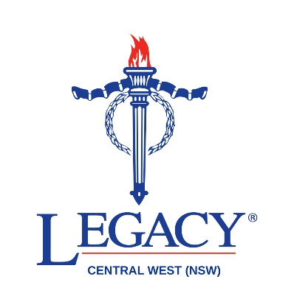

Legacy Central West (NSW)
Scholarship Application

Terms and Conditions

What our scholarships provide
The Legacy Central West (NSW) tertiary scholarship provides the successful applicant with a benefit of $5,000 for their first year of full-time tertiary study and increases each year up to and not exceeding $6,000 in years 3 and 4.

The Legacy Central West (NSW) vocational training scholarship provides the successful applicant with a financial benefit of up to and not exceeding $3,000 per annum to enrol in vocational training (including apprenticeships) at TAFE or another registered training organisation (RTO), purchase resources and assist with the completion of their chosen qualification.

Scholarships for short or part-time study at TAFE or another registered training provider are also provided.

If you are intending to apply for financial support for other forms of study (e.g. in sport or the creative or performing arts, please contact us at admin@orangelegacy.com.au or 02 6362 1205.

Eligibility
To be eligible to apply for this scholarship you must meet the following criteria:
- Be under the age of 25
- Be an Australian permanent resident and a resident of the Central West NSW region
- Be the direct descendant or adopted child of a person with service of one or more years as a member of the Australian Defence Forces or the direct descendant of an Allied veteran or Australian Mariner with operational service.
- Enrolled or planning to enrol at TAFE, university, other registered training provider.

Selection Criteria
- Demonstrated commitment to further education and career development
- Evidence of your need for financial support and encouragement.

Required Documentation
If called for an interview, you will be asked to supply:
- A copy of the veteran's Discharge Certificate or the name, service number, rank and unit of the family member who served, or a currently serving member of the Australian Defence Forces.
- Recent payment summary
- If employed, copies of two (2) recent payslips
- Details of parents' payment summaries (when applicable)
- Evidence of academic performance at school and/or university, etc.

Contact Details
If you have any questions regarding the scholarship application process, please contact Legacy Central West (NSW) directly via phone or email.

Phone: (02) 6362 1205
Email: admin@orangelegacy.com.au


